**2006-2013 Miata Appearance Package: Spotters Guide**

**2006-2008**

The appearance package on the third generation Miata included a front air dam, side skirts and a rear diffuser or “under skirt” as Mazda called it. In 2006 it was an orderable option package. In 2007 it was a dealer installed accessory, so a customer could conceivable have just the rear diffuser or the front air dam.

This first picture shows the front air dam and the side skirts.

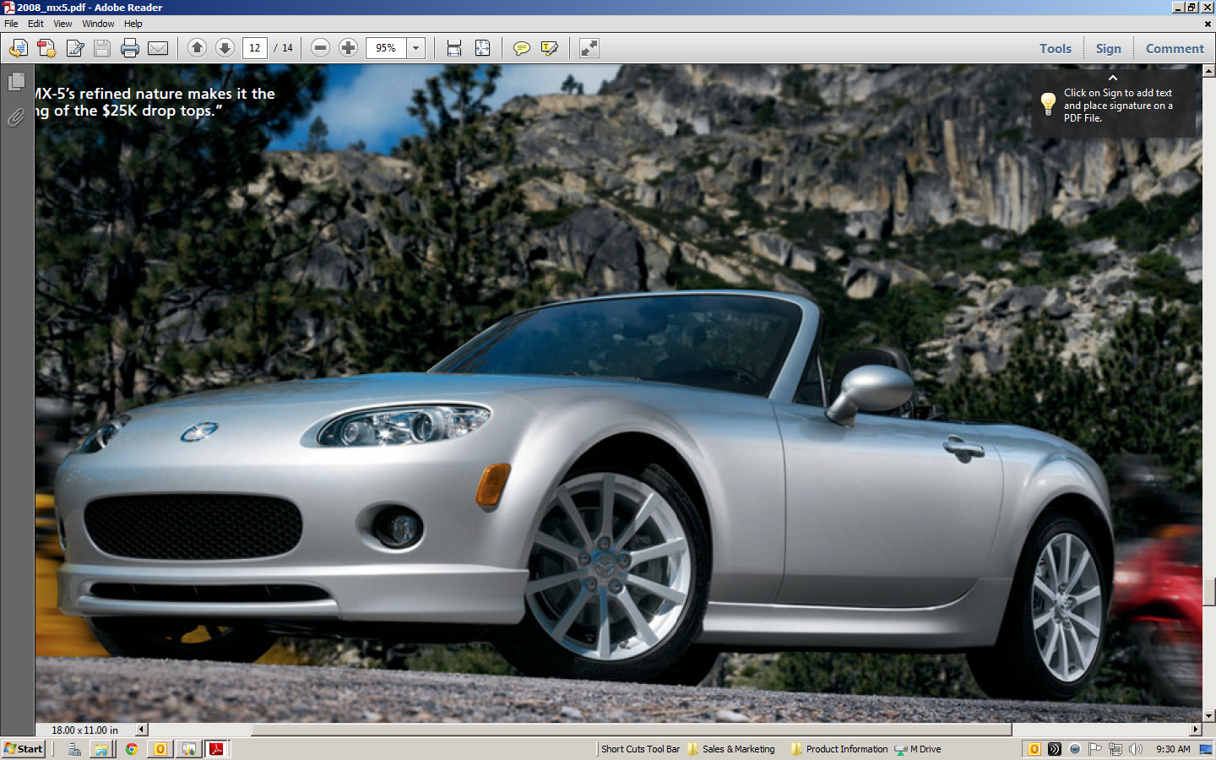

For reference here is a standard car without the appearance package.

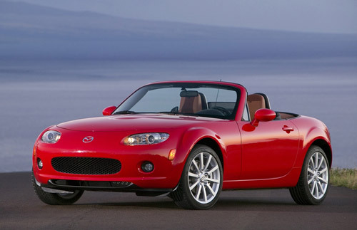

This picture shows the rear diffuser. Notice the very distinct line or seam that runs along the bumper. Non-appearance package cars do not have that seam.

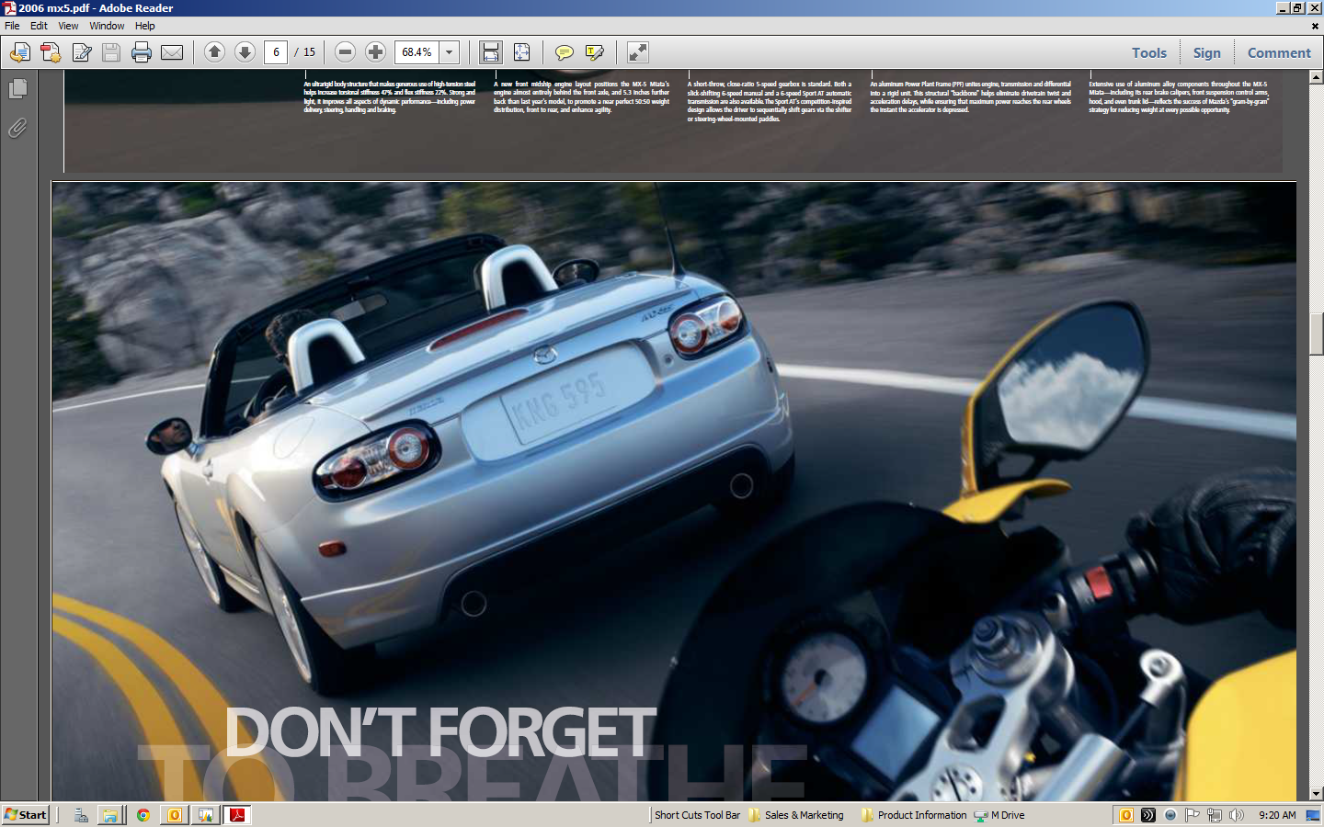

For reference here is a standard car without the appearance package.

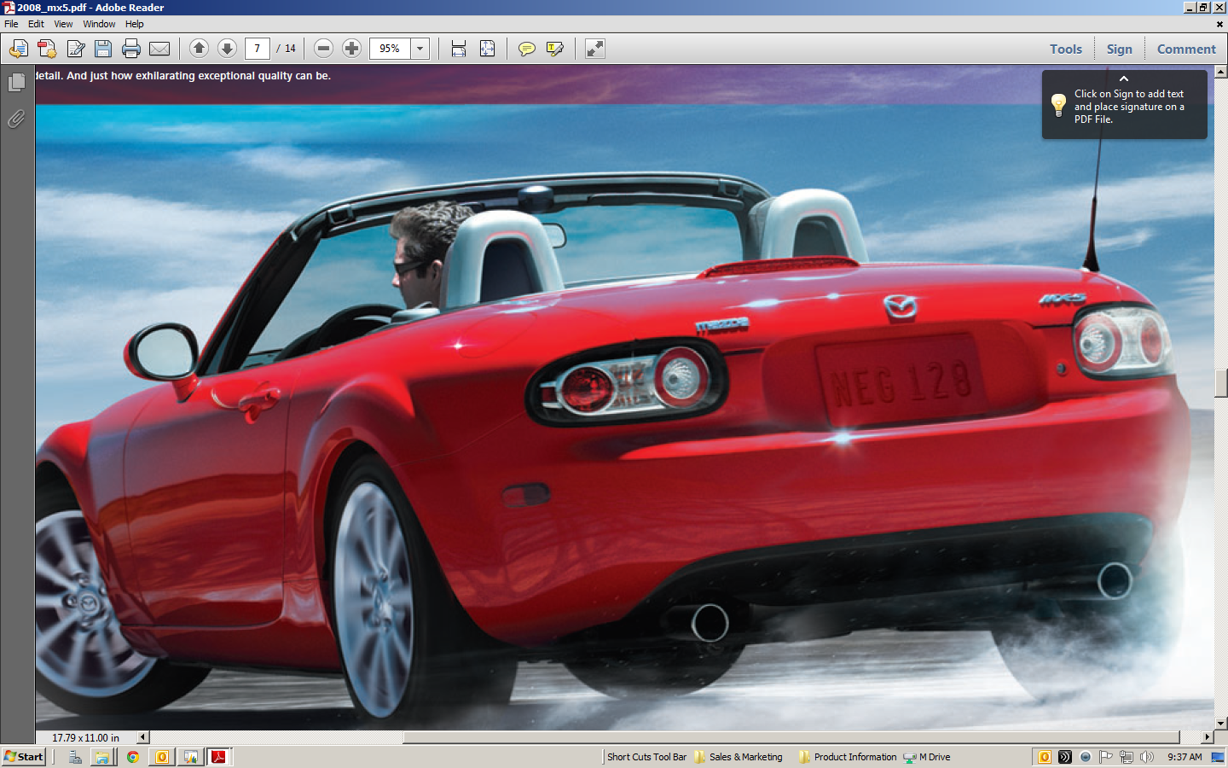

**2009-2012**

In 2009 there was a face lift to the car and with the face lift Mazda decided to re-introduce the appearance parts as a package rather than a dealer installed accessory. The package was available on all models. After 2009 the parts became dealer accessories again.

Below is what the appearance package rear bumper skirt looks like. The rear skirt is a little harder to spot on these cars as the large seam that was present on the earlier cars is gone.

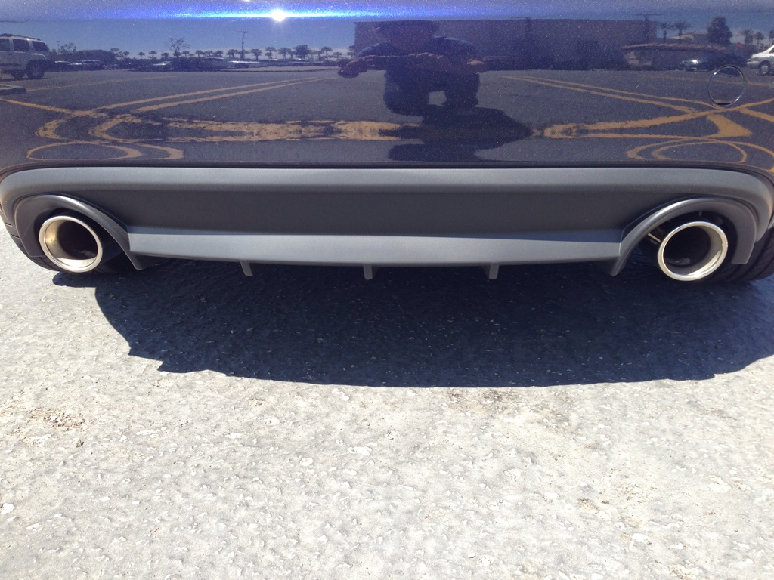

For reference here is a standard car without the appearance package.

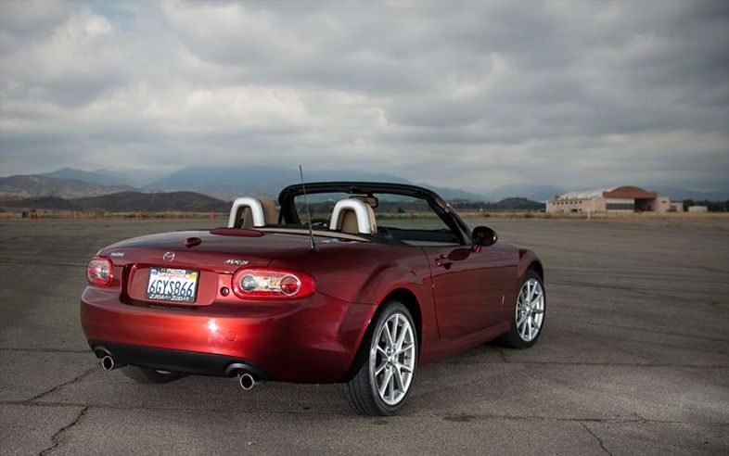

The front air dam is easiest to spot if you look for the seam underneath the fog lamps.

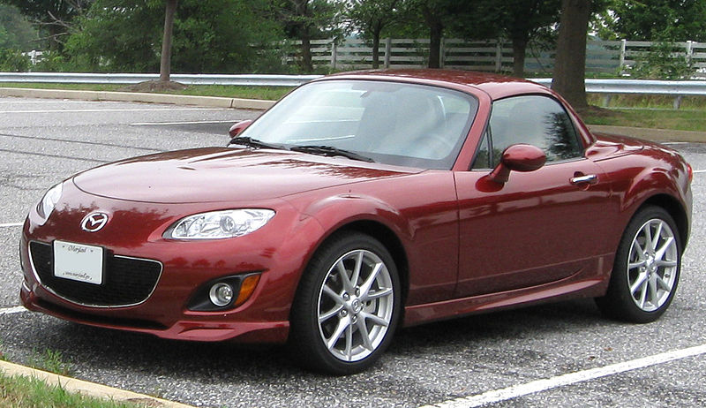

Here is a non-appearance package car for comparison



**2013-present**

Currently the only option is a front air dam. The best way to spot the air dam is the difference is color between the body and the air dam. The air dam, like the R package lip from the NA cars, is a matte black and not painted to match the body.

